Task Management Application

Software Architecture Document

Software Architecture Document

# Introduction

This document provides overview and explains the user interface architecture of the Task Management Application. The document defines goals of the architecture, the use cases supported by the system, architectural styles and components that have been selected. The document provides a rationale for the architecture and design decisions made from the conceptual idea to its implementation.

## Purpose

This document describes the architectural design for the Task Management Application.

## Scope

An application architecture describes the patterns and techniques used to design and build an application. The architecture gives you a roadmap and best practices to follow when building an application, so that you end up with a well-structured app. Software design patterns can help you to build an application

## *Software design architecture*

## 

This is task management application easy to use. User can allow create of lists with ability to add task cards as needed. This application also allows moving cards across lists. Task cards allow users to write their tasks and set appropriate status.

## *Architecture Component Details*

In this architecture diagram, user get the details about the component in task management application. Following diagram describes the component as per the user requirement.

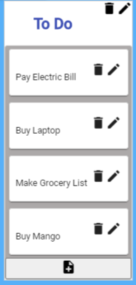

*Diagram of card 1*

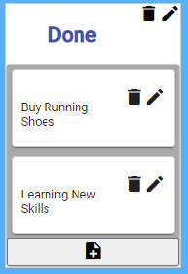

*Diagram of card 2*

## *Validation*

User can add new card using add list. Functional task app also allows validate editing task and list names. Appropriate validations are added to prevent duplicate named lists. Test the functionality to drag lists (with all cards) besides task dragging capability. validate appropriate tests and coverage. Validation with responsive without any horizontal scroll. Validate Enable keyboard-based usage.

## *User Experience*

User can perform following action in this application

* User can create and edit a list. User add name for the list with mandatory.
* User can delete a list. In the application with user a confirmation, if user selects Yes, will delete the list. User can add a card to any list.
* When user clicks Add a Card, user will be asked to provide Name for the card. Name is mandatory. Can move a card to next list.
* User can delete a card with user confirmation, if user selects Yes, will delete the card.

## *Sample Application Diagram:*

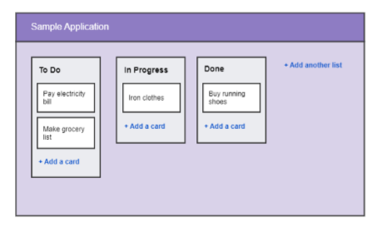

## *Enhancements:*

* Can polish the user interface with more functionality like connecting to the server. Application of lazy loading concept.
* Can split the code with different module.
* Can give sharing facility to web, mail and printing to do list.